5/31/2024

* Nour: 6 with filter per game, 7-d, 7-e
* Fer: do all the tables for % conversion, 7-a, as second priority, clean marketing data
* Jiani: 3, 4 - will email Winnie that ones that are ready
* Pedro: needs to add matches finished, and 5, check if we have CLICKS

6/10/2024:

* Nour: 10
* Fer: 8-b , 11-a, revisit 5

**LEGEND:**

**DONE**

**PARTIALLY DONE**

**WORK IN PROGRESS**

1. General Analysis

No breakdown in this session. We need two filters though: date and game. If filtered by game, DAU should reflect all the distinct players that started a specific game on a given day.

* 1. ✅DAU and MA7 (x: calendar date, y: DAU) - this DAU should only reflect login
  2. ✅Number of DISTINCT players that started a match and MA7 (x: calendar date, y: number of players that started a match) - done
  3. ✅Revenue per type (x: calendar date, y: $) - done
  4. Weekly retention table (something like this): 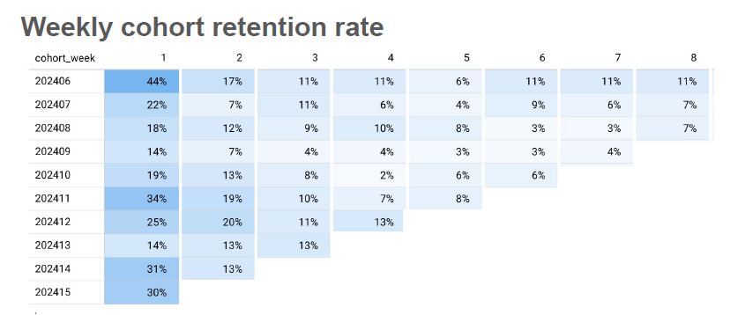
  5. ✅Number of matches started - multiplayer vs. solo (2 different lines) - MA7 (x: calendar days, y: number of matches) - done

1. (USER) Analysis by User Type (Returning vs. New)

All the charts below should have the “returning vs. new” separation (2 different lines). All cohorts should observe a 14-day behavior.

The charts should always reference the same color. For example, if returning has the color red, it should be red on all the charts that are referencing returning users.

* 1. ✅DAU and MA7 (x: calendar date, y: DAU) - yes: DAU_by_activity under gold
  2. ✅Average Playtime per user and MA7 (x: calendar date, y: average time in minutes)
  3. ✅Number of players that started a match - MA7 (2 different lines) (x: install date, y: number of players that started a match) - done

1. (USER) Analysis by Acquisition Type (Paid vs. Organic)

Same charts as 2, but divided between paid and organic users.

* ✅ DAU: yes : DAU_by_acquisition under gold : just need to aggregate
* ✅Average playtime per user: yes: playtime_by_acquisition under gold : just need to aggregate
* ✅% Conversion of downloads to matches started - MA7 (x: install date, y: number of installs on that date / (number of users who downloaded the app on that date and played a match)) - yes, player_count under gold? Have organic and paid counts but are these counts for people logging in or for actually starting a match? – yes
* % Conversion of downloads to multiplayer matches started - MA7 (x: install date, y: number of installs on that date / (number of users who downloaded the app on that date and played a multiplayer match)) - done
* % Conversion of downloads to payers - MA7 (2 different lines) (x: install date, y: number of installs on that date / (number of users who downloaded the app on that date and made a payment)) done
* ✅% Conversion of downloads to adding a friend (2 different lines) (x: install date, y: number of installs on that date / (number of users who downloaded the app on that date and added at least one friend) - done “download_to_add_friend_by_acquisiton” -done

1. (USER) Analysis by Platform Type (iOS vs. Android)

Same charts as 2, but divided between iOS and Android users.

* ✅DAU: completed - done DAU by platform
* ✅Average playtime per user: done completed - Playtime_by_Platform

✅Number of players who started a match: yes, player_count under gold

Started vs finished: not done

Conversion to multiplayer: yes: download_to_multiplayer_matches

Conversion to payers: yes: downloads_to_paying_users

✅Conversion to adding a friend: - done “download_to_add_friend_byplatform”

1. (MATCHES)

We need two filters here: GAME and CALENDAR DATE. If no filter is set, we will have a line per game (several colors).

1. Number of matches started of the game(s) during that day (x: calendar date, y: number of matches) – start tutorial also counts as start the game
   1. number of matches started – player_count under gold
   2. Question: Played_match under onboarding_ events (under analytics) – this is only for users who are onboarding? – fernando : done
2. Number of matches finished of the game(s) during that day (x: calendar date, y: number of matches)
   1. number of finished matches – could it be games_finished under Prodstats (can aggregate by game)? Or matches_ended under users_view? Or total_matches under match_stats
3. % matches started AFTER tutorial the match per game during that day (x: calendar date, y: (number of matches / number of started matches) – this HAS to be a number smaller than 1)
   1. number of matches started – player_count under gold
   2. ❓number of total matches – games_finished under ProdStats? Or total_matches under match_stats
4. % matches PLAYED at least one round (AFTER tutorial, after at least one round) per game during that day (x: calendar date, y: (number of finished matches / number of started matches) – this HAS to be a number smaller than 1)
   1. number of matches started – player_count under gold
   2. number of finished matches – games_finished under ProdStats?
5. % completion of matches per game during that day (x: calendar date, y: (number of finished matches / number of started matches) – this HAS to be a number smaller than 1)
   1. Is this the same as (d)?
6. (MATCHES) Multiplayer Analysis

We need two filters here: GAME and CALENDAR DATE. If no filter is set, we will have a line per game (several colors).

* 1. Number of MULTIPLAYER matches started of the game(s) during that day (x: calendar date, y: number of matches) – table done (match_multiplayer_game)
     1. total_count under player_count_multiplayer
  2. Number of MULTIPLAYER matches finished of the game(s) during that day (x: calendar date, y: number of matches)
     1. Don’t have a number of finished matches for multiplayer

1. (USERS x GAMES) Player Cycle

The number of users doing something during that day should always be lower than that day’s DAU.

Filter: game, date

* 1. Number of DISTINCT users who PLAYED the game(s) that day (x: calendar date, y: number of DAU who did this)
     1. number of Playpiece -User plays a game piece, game name, time spent, and action name.(on the log document)
     2. Total number of users - double counted – nour created
  2. Number of DISTINCT users who CLICKED on the game(s) during that day (x: calendar date, y: number of DAU who did this) - table done (distinct_player_clicked)
     1. GameChoose
  3. Number of DISTINCT users who JOINED a room that had at least one person during that day (x: calendar date, y: number of DAU who did this) - table done (distinct_users_join_room_one_plus_people)
     1. ConnectedToRoom- User connects to a room, recording game and connected users.
     2. We have JoinRoom – user joins a room, recording success status.

1. Revenue Per User Analysis
   1. Average Revenue Per Paying User(ARPPU) (x: calendar date, y: total revenue/number of payers)
      1. Already have ARPPU table - done
   2. Average Revenue Per Paying User by acquisition type (x: calendar date, y: total revenue/number of payers, group by acquisition type - different color)
      1. Already have ARPPU - done
      2. Also have acquisition type - perhaps need to do ARPPU by acquisitions
2. (USER) Analysis by Marketing type
   1. CPI (Cost Per Install): cost incurred to acquire a new user who installs the game.

(x: marketing campaign type, y = total cost of marketing campaign/ the number of installs generated from that campaign)

* 1. CPA (Cost Per Action): cost associated with a specific action taken by a user, such as playing at least one round - (x: marketing campaign type, y = total cost of marketing campaign/ number of campaign-generated users who completed at least one round)
  2. CPM (Cost Per Mille): cost per 1000 impressions of an advertisement. (x: ad type, y: (total costs/total impression) *1000

1. (USER) Analysis by customization options
   1. x: calendar date, y: number of users who changed their name
   2. x: calendar date, y: number of users who changed their avatar
   3. (the day someone changed their avatar - install date) – frequency table of how many days it took a user to do customization
      1. EditName (under onboarding_events under analytics) - distinct user
      2. EditAvatar (under onboarding_events under analytics) - distinct user

ConfirmProfile - User confirms their profile, recording success status.

Query: silver_table – event_name

1. (Tutorial) Analysis by games (if tutorials turn out to be important)
2. x: calendar date game name, y: number of users finished game tutorial/ total number of users who started on tutorial in a given time period
   * 1. We have StartedTutorial- records the start of a tutorial match, including match ID and game name. (on the log document but not on Bigquery)

Notes/suggestions for columns/variables to consider:

* We don't have numb of unique users - can we make every download have a unique id that we can track? Can make a table for users only with columns such as download date, app deletion date, average play time, etc, per user
* returning users isn't well defined: is it returning from yesterday or from a year before
* Need to differentiate users by creating a new column: important, very important, trackable etc for those who contribute heavily to our analysis: ones who purchase, ones who stay longest on app etc
* Frame necessary questions outside of the context of what data we have

Pedro's Suggestions:

* First Session Info: [Graphs here should help us improve the first session, therefore, acquisition]. It would be great to filter for [specific date ranges] paid/organic, or by continent, or android/ios.
  + 1st session Playtime graph:

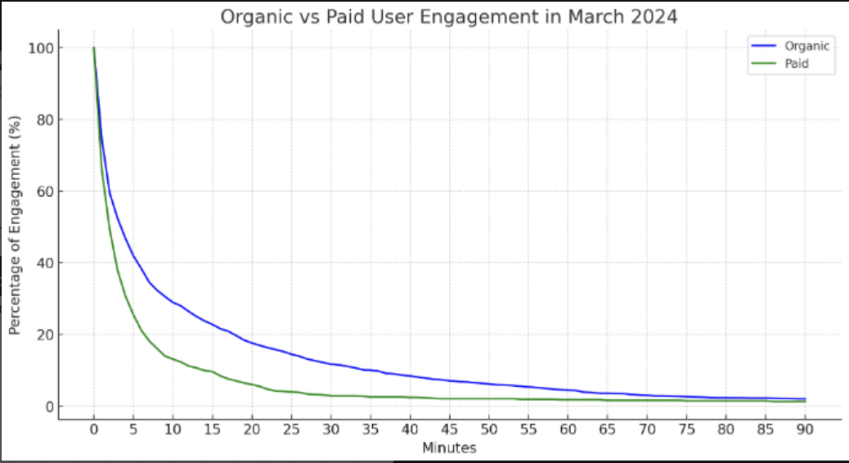

With this graph I will look if a new version improved the first impression users had on the app.

* First session games distribution

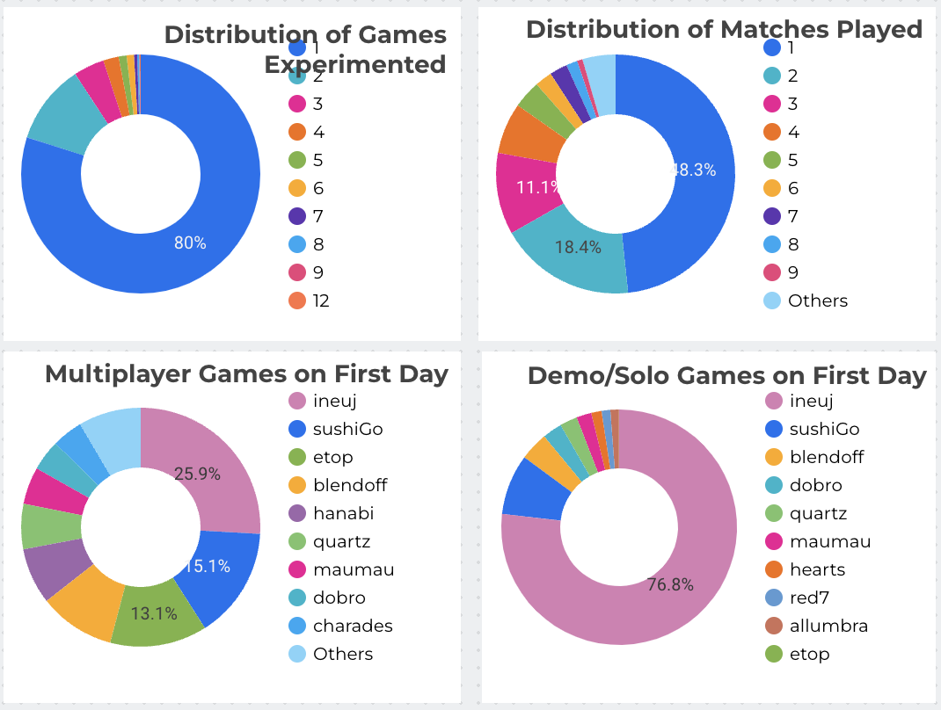

* User Persona Analysis: Now that we have a form that the user indemnify themselves as friend/family/solo, we could compare a bit their behavior

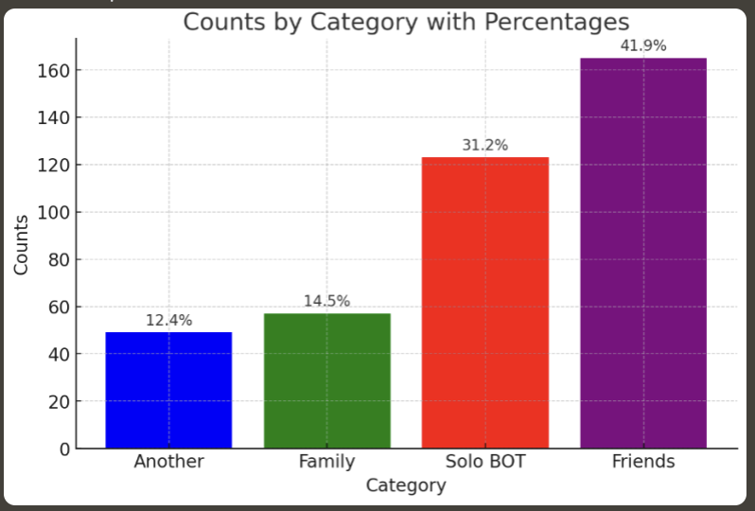

* Days Active in the first month (which group plays more frequently?)
* % conversion rate to payer per group
* Games distribution
  + (which game is the most played by each group?)
  + Does any group here plays only one game or they play several?
* Product KPI: We should be able to quickly see how we are performing / how sustainable we are:
  + This means showing [ ARPU (28) vs CPI ] per acquisition date.
  + ARPU Breakdown:
    - Conversion Rate graph (conversion to payer)
    - ARPPU 28
  + Subscription performance:
    - % users that from free trial pay the first month/year
    - Subscription churn: (% users that paid last month that stopped paying this month. Do not count users on free trial here)